Chapter 01
Introduction
1.1.1 Introduction to Software
Software
Instructions given to a computer (computer programs) Software is a general term for the various kinds of programs used to operate computers and related devices.
- Systems software
- Application software
Software is the set of instructions that makes the computer work.
Example - When you type in words via the keyboard, the software is responsible for displaying the correct letters, in the correct place on the screen.
Software is held either on your computer’s hard disk, CD-ROM, DVD or on a diskette (floppy disk) and is loaded (i.e. copied) into the computer’s RAM (Random Access Memory), as and when required

1.1.2. Types of Software
System Software:
System software is a collection of programs is written to service the other programs. Eg: Operating system component, drivers, telecommunication process.

Real Time Software:
Software that monitor / analyzes / control real-time world events as they occur is called it. Elements of real-time software include a data gathering components that and formats information an external environment.

Business software:
System have evolved into management information system software that access one or more large database containing business information.

Embedded software:
Embedded software resides in read-only memory and is used to control product and system for the customer and industrial markets.

Engineering and scientific software:
They have been characterized by number crunching algorithms.
Personal computer software:
Personal computer software market has burgeoned over the past two decades. Word processing, spreadsheets, computer graphic, multimedia and db management

Web-based software:
The network becomes a massive computer providing an almost unlimited software resource that can be accessed by anyone with a modem.

Artificial intelligence software:
AI software makes use of non- numerical algorithms to solve the complex problems that are not amenable to computing or straightforward analysis.

1.1.3. Characteristics of Software
- Intangibility-Cannot touch software.
- Increase use will not introduce any defects.
- Software is configurable-able to build software by combining a basic set of software components in different ways.
- One can change the product easily by re-implementing it without changing the design.
- Custom built- Most software are made upon order

Costs of Hardware vs. Software:
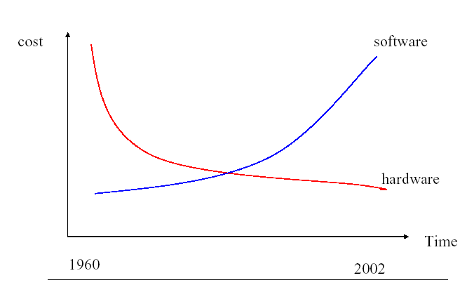

Failure curve for hardware [Pressman]
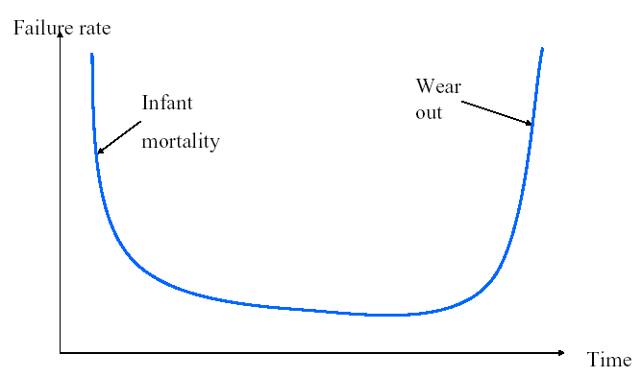

Failure curves for software - Pressman
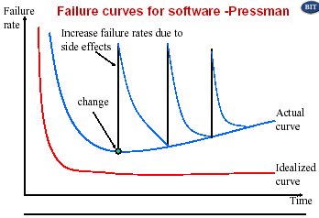

1.1.4. Attributes of Good Software
Software Quality
The degree in which software possesses a desired combination of quality attributes.
The software should deliver the required functionality and performance to the user and should be maintainable, dependable and acceptable.
–Maintainability
• Software must evolve to meet changing needs;
– Dependability
• Software must be trustworthy;
– Efficiency
• Software should not make wasteful use of system resources;
– Acceptability
• Software must accepted by the users for which it was designed. This means it must be understandable, usable and compatible with other systems.

Bohem’s Classification
- Current Usefulness
The qualities expected from a software system in user’s point of view.
- Potential Usefulness
The qualities expected from a software system in developer’s point of view.

Current usefulness
- Efficiency-Software should not make wasteful use of system resources
- Reliability
- Usability
- Correctness-The degree with which software adheres to its specified requirements.
- User friendliness
- Robustness

Potential usefulness
- Maintainability - Software must evolve to meet changing needs. The ease with which changes can be made to satisfy new requirements or to correct deficiencies.
- Modularity -
- Reusability - The ease with which software can be reused in developing other software.
- Portability - The ease with which software can be used on computer configurations other than its current one.

McCall’s Classification
- Product operation
- Product revision
- Product transition

Product Operation
- Efficiency - The degree with which software fulfills its purpose without waste of resources.
- Correctness -
- User friendliness -
- Usability -
- Reliability - The frequency and criticality of software failure, where failure is an unacceptable effect or behavior occurring under permissible operating conditions.
- Robustness -

Product Revision
- Maintainability
- Flexibility
- Testability

Product Transition
- Interoperability
- Reusability
- Portability

1.2.1. Introduction to Software Engineering

Need for software engineering
- The economies of ALL developed nations are dependent on software.
- More and more systems are software controlled
- Expenditure on software represents a significant fraction of GNP in all developed countries.
- Software engineering is concerned with theories, methods and tools for professional software development.
- Software is found in products and situations where very high reliability is expected – E.g. Monitoring and controlling Nuclear power plants
- Contain millions of lines of code
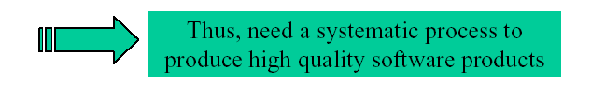
- Comparably more complex

A Solution – Software Engineering:
- Greater emphasis on systematic , scientific development
- Computer assistance in software development (CASE)
- A concentration on finding out the user’s requirements
- Formal/Semi Formal specification of the requirements of a system.
- Demonstration of early version of a system (prototyping)
- Greater emphasis on development of error frees easy to understand code.

What is software engineering?
- An engineering discipline that is concerned with all aspects of software production
- Software engineers should adopt a systematic and organized approach to their work and use appropriate tools and techniques depending on the problem to be solved, the development constraints and the resources available.

Software Engineering
Definition:
Simple definition: Designing, building and maintaining large software systems.

Others
=> ‘Software engineering is concerned with the theories, methods and tools for developing, managing and evolving software products’. - I Summerville
=> ‘The practical application of scientific knowledge in the design and construction of computer programs and the associated documentation required to develop, operate and maintain them’. - B.W.Boehm
=> ‘ The establishment and use of sound engineering principles in order to obtain economically software that is reliable and works efficiently on real machines’. - F.L. Bauer

=> ‘The application of systematic, disciplined, quantifiable approach to the development, operation, and maintenance of software’ - IEEE Standard 610.12

Software Engineering – Definition
‘Use of systematic, engineering approach in all stages of software development and project management to develop high quality and economical software using appropriate software tools.’

What makes software special?
The main difference in software engineering compared to other engineering disciplines is listed below.
- It is difficult for a customer to specify requirements completely.
- It is difficult for the developer to understand fully the customer needs.
- Software requirements change regularly
- Software is primarily intangible; much of the process of creating software is also intangible, involving experience, thought and imagination
- It is difficult to test software exhaustively.

1.2.2. Software Engineering Costs
Software Engineering Costs
- Distribution of costs across the different activities in the software process depends on the process used and the type of software that is being developed
Eg: Real-time software usually requires more extensive validation and testing than web-based systems.
- In the waterfall approach, the cost of specification, design, implementation and integration are measured separately. System integration and testing is the most expensive development activity. Normally this is about 40% of the total development costs.
Development Failures
IBM Survey, 2002
- 55% of systems cost more than expected
- 68% overran the schedules
- 88% had to be substantially redesigned
Bureau of Labour Statistics (2004)
- for every 6 new systems put into operation, 2 cancelled
- probability of cancellation is about 50% for large systems
- average project overshoots schedule by 50%

Over Budget
Home Office IT project millions over budget
Home Office (UK) IT project run by Bull Information Systems is expected to blow its budget by millions of pounds and is hampered by a restrictive contract, according to a leaked report. The National Audit Office Report is expected to reveal damning evidence that the project to implement two systems – the National Probation Service Information System, and the Case Record and Management System will cost 118m pounds by the end of the. year, 70% over its original budget.

Over Schedule
New air traffic system is already obsolete
National Air Traffic Services (Nats) is already looking at replacing the systems at its new control center at Swanwick in Hampshire, even though the system doesn’t become operational until next week. This project is six years late and 180m pounds over budget.
Swanwick was originally meant to be operational by 1997, but problems with the development of software by Lockheed Martin caused delays, according to Nats.

Safety – London Ambulance Dispatching System
The full introduction of the computer system effectively did away with the radio and telephone calls to stations, with the computer dispatching crews to answer calls. But within hours, during the morning rush, it became obvious to crews and control room staff that calls were going missing in the system; ambulances were arriving late or doubling up on calls. Distraught emergency callers were also held in a queuing system which failed to put them through for up to 30 minutes. Chris Humphreys, Nupe’s divisional officer, said that it was hard to verify how many people might have died because of the delays but it could be as many as 20.

Causes:- The managers who produced the software were naïve. They made a terrible mistake of trying to go on-line abruptly, without running the new and old systems together for a while.

Programming/testing Error – Ariane 5 (June 1996):
It took the European Space Agency 10 years and $7 billion to produce Ariane 5, a giant rocket capable of hurling a pair of three ton satellites into orbit.

At 39 seconds after launch, as the rocket reached an altitude of two and a half miles, a self-destruct mechanism finished off Ariane 5, along with its payload of two expensive and uninsured scientific satellites. The rocket was making an abrupt course correction that was not needed, compensating for a wrong turn that had not taken place.

The cause (Ariane –5)
Steering was controlled by the on-board computer, which mistakenly thought the rocket needed a course change because of the numbers, which in fact was an error, coming from the inertial guidance system. The guidance system had in fact shut down 36.7 seconds after launch, when the guidance system’s own computer tried to convert one piece of data – the sideways velocity of the rocket – from a 64 bit format to a 16 bit format = overflow error.

The Statistics
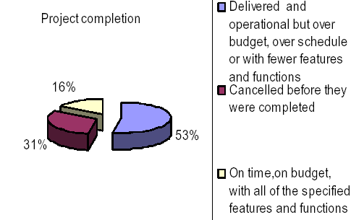

1.2.3. Key Challenges facing software Engineering
Key challenges facing software engineering?
Heterogeneity, delivery and trust
- Heterogeneity
  - Developing techniques for building software that can cope with heterogeneous platforms and execution environments
- Delivery
  - Developing techniques that lead to faster delivery of software
- Trust
  - Developing techniques that demonstrate that software can be trusted by its users.

Software Problems
- Time Schedules and cost estimates of many software projects are grossly inaccurate.
- Software is costly
- The quality of software is not satisfactory.
- Software is difficult to maintain.
- The productivity of software people is not satisfactory to meet the demand.
Problems of software development
  - Large software is usually designed to solve 'wicked' problems
  - Software engineering requires a great deal of co- ordination across disciplines
    - Almost infinite possibilities for design trade-offs across components
    - Mutual distrust and lack of understanding across engineering disciplines
  - Systems must be designed to last many years in a changing environment
  - The process of efficiently and effectively developing requirements
  - Tooling required to create the solutions, may change as quick as the clients mind.
  - User expectations:
    - User expectations increase as the technology becomes more and more sophisticated.
  - The mythical man-month factor:
    - Adding personnel to a project may not increase productivity.
    - Adding personnel to a late project will just make it later.
  - Communications:
    - Communications among the various constituencies is a difficult problem. Sometimes different constituencies speak completely different languages. For example, developers may not have the domain knowledge of clients and / or users. The larger the project, the more difficult the communications problems become.
Project characteristics:
- size / complexity
- novelty of the application
- response-time characteristics
- security requirements
- user interface requirements
- reliability / criticality requirements

1.2.4. Systems engineering & software Engineering
What is the difference between software engineering and system engineering?
- System engineering - is concerned with all aspects of computer-based systems development including hardware, software and process engineering.
- Software engineering - is part of this process concerned with developing the software infrastructure, control, applications and databases in the system.
- System engineers - are involved in system specification, architectural design, integration and deployment.
1.2.5. Professional Practice
Professional and ethical responsibility:
- Software engineering involves wider responsibilities than simply the application of technical skills.
- Software engineers must behave in an honest and ethically responsible way if they are to be respected as professionals.
- Ethical behavior is more than simply upholding the law.
Issues of professional responsibility:
- Confidentiality
- Engineers should normally respect the confidentiality of their employers or clients irrespective of whether or not a formal confidentiality agreement has been signed.
- Competence
- Engineers should not misrepresent their level of competence. They should not knowingly accept work which is out with their competence.

Issues of professional responsibility:
- Intellectual property rights
- Engineers should be aware of local laws governing the use of intellectual property such as patents, copyright, etc. They should be careful to ensure that the intellectual property of employers and clients is protected.

- Computer misuse
- Software engineers should not use their technical skills to misuse other people’s computers. Computer misuse ranges from relatively trivial (game playing on an employer’s machine, say) to extremely serious (dissemination of viruses).

Software Maintenance:
Any software system needs to be changed. Maintenance is the costliest operation in the software development process (about60%). Software need to be changed due to various reasons.

Errors in the system.
Changes in the user requirements
Availability of new technology
Changes in the enterprise or Govt. policy.

What is the difference between software engineering and system engineering?:
System engineering is concerned with all aspects of computer-based system development, including hardware, software and processor engineering.
Software engineering is concerned with developing software

